1. **HTML Task**
   1. **What is HTML? Give basic structure of the HTML page.**

HTML is a language of the web. It’s used to design the web pages or we can say structure the page layouts of a website. HTML stands for HYPERTEXT MARKUP LANGUAGE, as its full form suggests it’s not any programming language, a markup language. So, while the execution of HTML code we can’t face any such error. In real HTML code wasn’t compiled or interpreted because HTML code was rendered by the browser. which is similar to the compilation of a program. Html content is parched through the browser to display the content of HTML.

* 1. **Difference between inline and block element.**

|  |  |
| --- | --- |
| **Block** | **Inline** |
| A block element begins on a new line. | It remains inline with all the text around the element and appears the same as inline. |
| Examples: div, p, li, main, etc. | It has no tag examples as it can be applied to any tag using CSS. |
| CSS property: display:block | CSS property: display:inline-block |

* 1. **Create an HTML page “index.htm” with following content**

Code:

<!DOCTYPE html>

<html lang="en">

    <head>

        <title>My first web page</title>

        <style>

            table, tr, td{

                border: 1px solid black;

            }

        </style>

    </head>

    <body>

        <h1>My first web page</h1>

        <h3>What this is</h3>

        <p>Welcome to my first  webpage I create this webpage withour the assistance of a webpage editor. Just my little text editor and a keen <b>understanding of html.</b></p>

        <h3>Why this is</h3>

        <ul>

            <li>To learn html</li>

            <li>List element</li>

            <ol>

                <li>Home</li>

                <li>FAQ</li>

                <li>Contact</li>

                <li>About</li>

            </ol>

            <li>Here I have created ordered and unordered list</li>

        </ul>

        <h3>ZeusLearning.com</h3>

        <a href="https://www.zeuslearning.com" target="_blank">This linke will open zeuslearning.com in new tab</a>

        <h4>On click of following image navigate to Google.com</h4>

        <a href="www.google.com">

            <img src="google-logo.png" alt="Google Logo" width="100px">

        </a>

        <p><b>Some random table</b></p>

        <table>

            <tr>

                <td>Row 1, cell1</td>

                <td>Row 1, cell2</td>

                <td>Row 1, cell3</td>

            </tr>

            <tr>

                <td>Row 2, cell1</td>

                <td>Row 2, cell2</td>

                <td>Row 2, cell3</td>

            </tr>

            <tr>

                <td>Row 3, cell1</td>

                <td>Row 3, cell2</td>

                <td>Row 3, cell3</td>

            </tr>

        </table>

        <p><b>Some random form</b></p>

        <p><b>Note:</b> It looks the part, but won't do a anything.</p>

        <form>

            <label for="name">Name:</label><br /><br />

            <input type="text" name="name" placeholder="Your name"><br /><br />

            <label for="comments">Comments:</label><br /><br />

            <textarea name="comments" id="" cols="30" rows="10" style="overflow-y:scroll;">Your comments</textarea><br /><br />

            <label for="gender">Are you:</label><br /><br />

            <input type="radio" name="gender" value="Male">Male</input><br />

            <input type="radio" name="gender" value="Female">Female</input><br /><br />

            <input type="submit" name="submit" value="submit query"><br />

        </form>

    </body>

</html>

1. **CSS Task**
   1. **Explain the different ways in which CSS can be applied to HTML, what is the preferred way and why.**

There are Four methods of adding CSS to HTML.

**Inline**: by inserting a style attribute inside an <head> element.

**Embedded/Internal**: by putting all css inside head using <style> tags

**Linked/External**: CSS is placed in an external .css file, and linked to the HTML document using a <link> tag.

**Imported**: Importing a CSS file using @import

External css is the most preferred way among all of the other ways because it helps to separate the html and css file which gives better understanding and scale to the code maintanance.

* 1. **What are different CSS selectors, with example explain Element, Class and Id selectors.**

Element Selector

Id Selector

Class Selector

Universal Selector

Group Selector

Attribute Selector

Pseudo-Class Selector

Pseudo-Element Selector

* Element Selector: The element selector selects HTML elements based on the element name (or tag) for example p, h1, div, span, etc.

Ex:

h1{

color: red;

font-size: 30px;

}

* Id Selector: The id selector uses the id attribute of an HTML element to select a specific element.

Ex:

#div-container{

color: blue;

background-color: gray;

}

* Class Selector: The class selector selects HTML elements with a specific class attribute.

Ex:

.paragraph-class{

color: white;

font-family: monospace;

background-color: purple;

}

* 1. **With the help of a diagram explain CSS Box Model.**

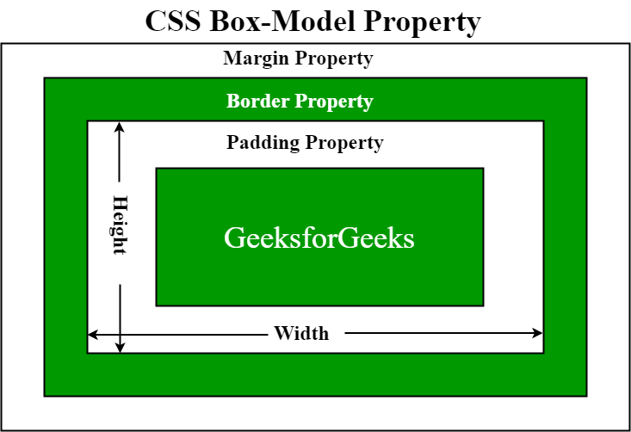

* **content:** This property is used to displays the text, images, etc, that can be sized using the width & height property.
* **padding:** This property is used to create space around the element, inside any defined border.
* **border:** This property is used to cover the content & any padding, & also allows to set the style, color, and width of the border.
* **margin:** This property is used to create space around the element ie., around the border area.
  1. **To HTML page create in the task 1.a, apply following CSS**

body{

    background-color:moccasin;

    padding: 0 10px;

}

.title{

    background-color: brown;

    color: white;

    text-align: center;

    border-bottom: 10px solid crimson;

    letter-spacing: 13px;

    font-style: italic;

}

.subtitle{

    background-color:limegreen;

    color: white;

    padding-left: 15px;

}

.span-text{

    font-style: italic;

    text-transform: uppercase;

}

.list{

    color: crimson;

}

.img-container{

    width: 100px;

    border: 1px dashed #777;

}

.subtitle-2{

    color: #999;

}

table{

    background-color: #888;

}

1. **Javascript Task**
   1. **List down ways in which JavaScript command can be added to a webpage, what is the preferred way.**
2. Embedding code
3. Inline code
4. External file

External File is the preffered way because it becomes very helpful if we want to use the same code in multiple HTML documents. It also saves us from the task of writing the same code over and over again and makes it easier to maintain web pages.

* 1. **To the webpage created in the task 2.d , on click of “Submit” button call JavaScript function to validate:**
* **Name and comments fields are not empty.**
* **User has selected one entry from male/female radio button**
* **In case user has not entered data for name and comment field or not selected anything from male/female radio button – show alert message “All fields are compulsory” and set focus to the first filed that is empty.**

function validateForm(){

    let name = document.forms["form"]["name"].value;

    let comment = document.getElementById("comments").value;

    let gender = document.getElementById("gender").checked;

    if(name=="" && comment=="" || comment=="Your comments" && gender==false){

        alert("all fields are compulsory!");

        document.forms["form"]["name"].focus();

        return false;

    }

    if(name==""){

        alert("Name field must be filled out!");

        return false;

    }

    if(comment=="" || comment=="Your comments"){

        alert("Comment field must be filled out!");

        return false;

    }

    if(gender == false){

        alert("Gender field must be filled out!");

        return false;

    }

}